**Project Name:** Predict Fuel Efficiency

**Github Link:** https://github.com/projectsforstudents2022/Predict_Fuel_Efficiency.git

**Why was this project created?**

As the vehicle business has expanded over the past 200 years and as gasoline prices have increased and consumers have become more picky about features, automakers are continuously improving their operations to improve fuel efficiency.

**What problem is it solving?**

The goal was to create a model that could accurately forecast a car's MPG. This model could also be used to identify unusual fuel economy in order to spot anomalous vehicles. Presenting a different approach to simulation models that anticipate the fuel efficiency of automobiles.

**Entire explanation of project**

* **PROPOSED APPROACH**

We will use a convolutional neural network in this project. Our data will undergo data cleaning as well as data preprocessing. A variety of graphs and plots will be used to display all data visualizations. Filling in any null units in the dataset and fixing any other errors are included in the cleaning of the data. Then, we'll build multiple models using different techniques and begin running the training process on the data. The different algorithms will be used to build each unique model. The values of the predictions will depend on how well the data were trained using those from the dataset. Testing will be conducted on datasets that contain datasets for MPG or the expected value for fuel efficiency.

In order to determine the most appropriate and effective model, the RMSE values of all the models will be compared. The models can be deployed after they are completed. The deployment method involves building a web page with the appropriate models and deploying them there. The user will either visit the page or provide new inputs according to their models to be checked whether they are from the car industry or a customer. The model will be fed the provided data, and projections for fuel economy will be computed in accordance with those results. Last but not least, the fuel economy or MPG, which is the expected output, will be shown on the screen.

Algorithm for creating next word prediction model :

**Step 1:** Import Libraries & Load Dataset

**Step 2:** Data Preprocessing

**Step 3:** Label Encoding

**Step 4:** Build CNN

**Step 5:** Train Model

**Step 6:** Testing & Visualization

* **DATA FLOW DIAGRAM**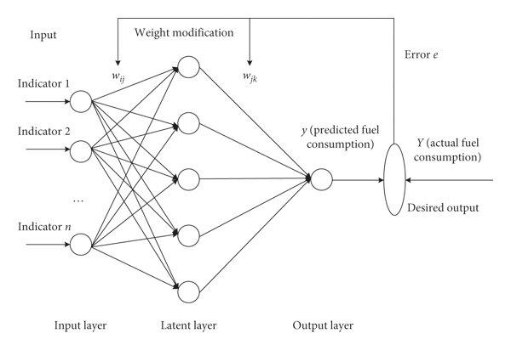
* **RESULT**

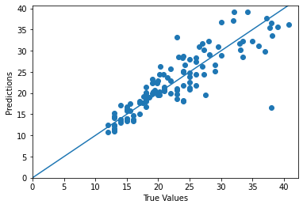

* **CONCLUSION**

We created a model that, given certain information about the car, could accurately forecast the mpg with a margin of error of 2.5 mpg. This model might be used to forecast competitor's future mpg ratings for incoming cars using data from more recent models, giving businesses the opportunity to employ resources currently allocated to R&D to create more efficient, more well-liked vehicles that outperform rivals.